- February 2019 variant2 Task3:
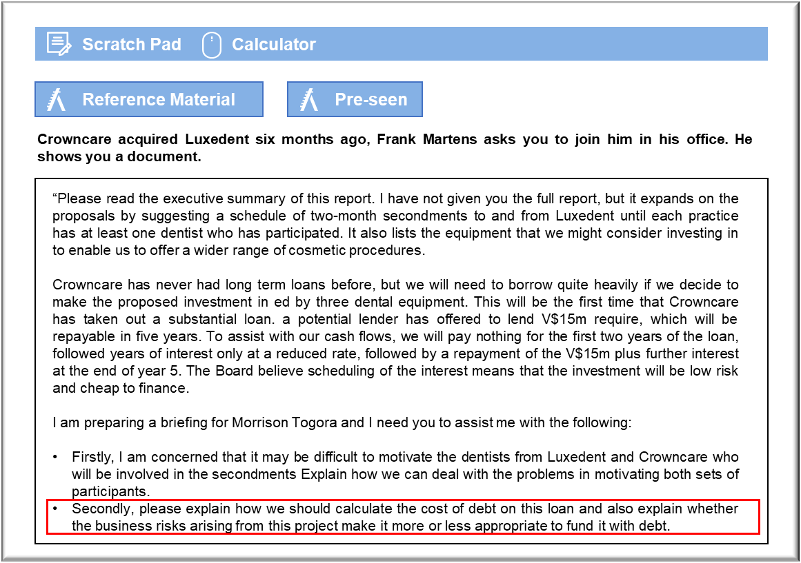

Motivation

Luxedent’s dentists may be concerned because their practice is relatively small compared to the rest of the Crowncare Group. They could easily spend a significant proportion of their time at other practices in coming months. It would help if the schedule for these secondments could be announced well in advance and shared so that no dentist spends too long away from Luxedent.

The dentists from Luxedent could be concerned that their patients will be unhappy that they will be away from the practice for an extended period. That could interfere with long-term treatment plans and affect patient goodwill. It might be encouraging to restrict the secondment to a few days each week, so that dentists can implement any continuing treatment plans agreed with patients.

Dentists from Luxedent may be concerned that the incoming dentists from Crowncare will be less competent and could lose patients. The scheme will have to involve training and supervision so that Luxedent’s practice will not suffer as a result.

Crowncare’s dentists may view the secondment as a sign of merit, which could lead to resentment from colleagues who are not selected. Not all dentists will have the opportunity to participate. Crowncare should set out clear criteria for the selection of dentists who will be selected for secondment. If merit or seniority is to play a part then that should be acknowledged so that there are no misunderstandings.
The dentists from Crowncare may be concerned that participating in the secondment will lead to them becoming classed as experts in cosmetic dentistry on their return and could affect their career paths if they become heavily involved in that area. Ideally, Crowncare should seek volunteers who are interested in cosmetic dentistry and who are keen to investigate this further.

Crowncare’s dentists may be concerned that their colleagues at Luxedent will treat them as inferiors. Crowncare’s practices are already involved in cosmetic dentistry and its dentists are skilled professionals. The focus of the secondment should be set out in detail, stressing that its purpose is partly to familiarise Crowncare dentists with equipment and techniques that is not available across the Corwncare Group.

Cost of debt and risk

The loan has an initial fair value of V$15m. Crowncare is prepared to accept that sum in return for its commitment to make the agreed payments for interest and principal and the lender is equally willing to accept that arrangement. The nominal rates of interest stated on the contract are not particularly relevant because of the deferred nature of the payments. The most logical way to measure the gross cost of debt would be to follow the guidance in IFRS 9 Financial Instruments on the calculation of effective interest. That would essentially be the rate of interest that would equate the initial V$15m to the subsequent payments of low-rate interest, accrued interests and the lump-sum repayment of the V$15m principal. The interest rate so determined would be used both in accounting for the loan for financial reporting purposes and would reflect the gross cost of the debt.

The cost of debt should be reduced to reflect the tax relief on the interest payments. This will simply offset the rate of corporation tax against the effective gross rate determined. The tax relief will not actually be received until the interest is paid, but that can be reflected for accounting purposes in the provision for deferred tax.

The business and financial risks are effectively linked to the future demand for the laser whitening service. The principal upside risk is that the machines will be fully occupied throughout their useful lives and will generate significant cash inflows. In the first instance, such a scenario would interact with the nature of the loan because the finance has been provided entirely by the bank and there are no outflows for first two years and only reduced payments for the next three. Such an arrangement will enable Crowncare to generate a substantial cash surplus that will, hopefully, be sufficient to repay the loan and accrued interest at the end of year five.

The downside risk is that the anticipated demand for tooth whitening does not materialise, or that technology will change and create cheaper or superior systems for competitors. In that case, the loan will still have to be repaid in accordance with the contract and so Crowncare’s future cash flows will be disrupted. If Crowncare cannot raise the full amount in time then it may be forced out of business. If this venture does prove to be loss-making then Crowncare may be unable to make full use of the tax relief on the debt and so the effective rate will increase.

